Wildcards in Linux
What are Wildcards in Linux?
Wildcards are special characters used in Linux command-line to match multiple files or patterns without typing full names.
They make file handling faster and more efficient.
Used with commands like:
ls, cp, mv, rm, find, grep etc.

Types of Wildcards
1️⃣ Asterisk *
- The asterisk (*) is the most commonly used wildcard in Linux.
It is used to match zero or more characters in a filename or string.
- It helps you work with multiple files without typing each filename fully.
Example:
- ls *.txt - Shows all files ending with .txt . Here by entering the command we can see all the files we have created.
- rm file* - Removes all files starting with file . Here by entering the command we have removed all the files.
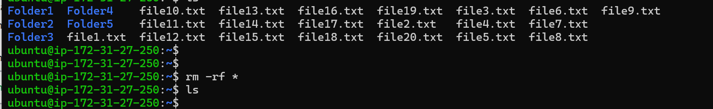

2️⃣ Question Mark ?:
The question mark (?) wildcard in Linux is used to match exactly one single character in a filename or pattern. It is useful when you know the length or partial structure of a filename but not the exact character.
Example:
- ls file?.txt - file1.txt, fileA.txt, file_.txt . Here we used command to see all the files specifically in single character file name and double character file name separetly.
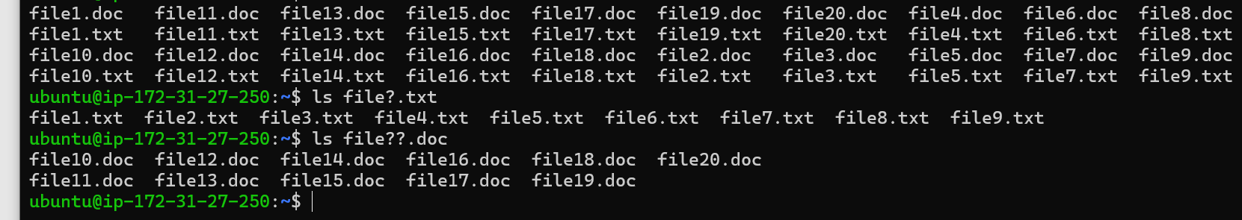
- rm file?.txt – file11.txt, file12.txt… Here we used commands to delete double character files ending with .txt as you seen below.
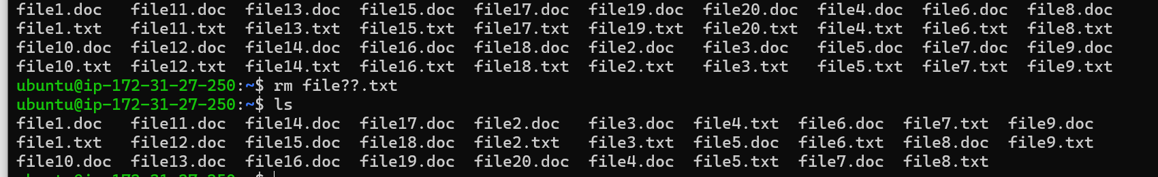
3️⃣ Square Brackets [ ]
- The square brackets ([ ]) wildcard is used to match exactly one character from a specific set or range.
It allows more control compared to the ? wildcard.
- Used when you want to match multiple similar filenames that follow a pattern.
Range possibilities:
- [A-Z] – Uppercase letters
- [a-z] – Lowercase letters
- [0-9] – Digits

Example:
- ls file[1-3].txt - file1.txt, file2.txt, file3.txt
- ls file[1-4].doc – file1.doc, file2.doc, file3.doc

4️⃣ Curly Braces { } (Brace Expansion):
Curly braces { } in Linux allow you to generate multiple text strings or file names in a single command.
- This is not technically a wildcard, but it is often used along with wildcards for pattern creation.
Example:
- touch file{1..20}.txt – file1.txt file2.txt ……. file20.txt

Where Wildcards Help Most
- Bulk file operations
- Searching and filtering files
- Automation and scripting
- Log file management (useful in SOC, DevOps)

Safety Tip:
- Be careful with rm + wildcard!
- rm -rf * - removes everything
- This removes all files in current directory ⚠️
- Always double-check before executing commands!
Conclusion:
Wildcards are powerful shortcuts in Linux that save time and simplify file management.
Mastering them makes working in the command line faster, flexible, and more efficient.

